MODULE 7: RDS

Sub-task 1 - Create RDS instance

Create an RDS instance in the private <ProjectName>-DbSubnet-RDS subnet created in [Module 6: VPC](https://epam-my.sharepoint.com/epmc-acm-public/aws-associate-training/-/blob/CloudX_Associate_AWS_Java_TShape_Developer_theory_impovements/courses/CloudX_Associate_AWS_Java_TShape_Developer/tasks/vpc/README.md). Choose creation method and engine type. **WARNING: Select a free-tier**

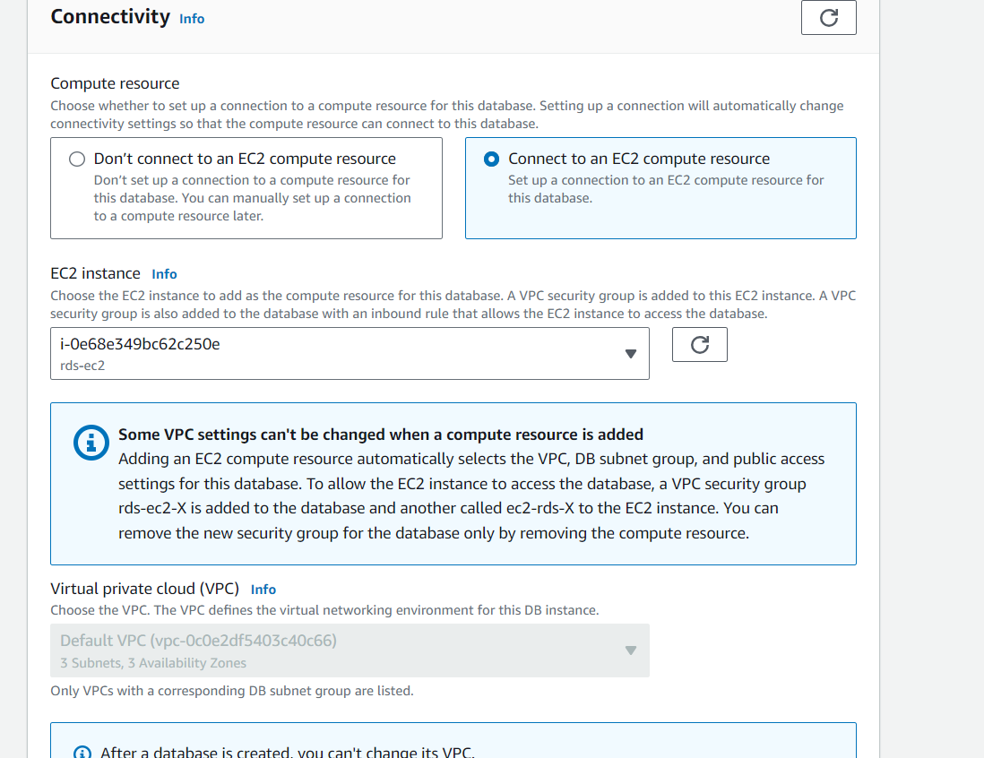

3. Ensure ***Main microservice*** EC2 instance has correctly configured security group to access RDS.

4. Make sure, ***Main microservice*** EC2 instance has access to already created RDS instance. Make some SQL queries to the RDS instance bypassing the web application over SSH.

**Sub-task 2 - Migrate your on-premise DB schema to RDS**

Use AWS’s Database Migration Service.

1. Created 2 rds databases (source,target)

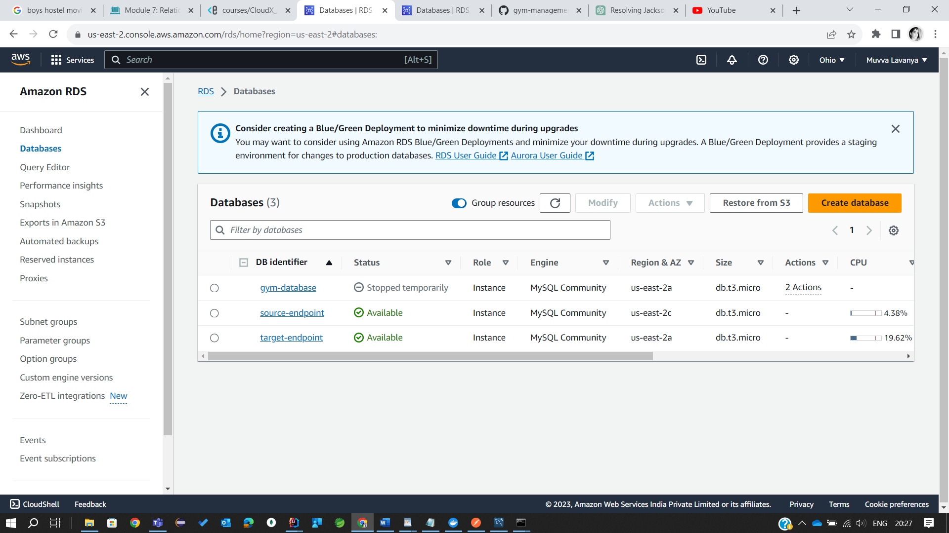

Established the connection locally

Data in the source endpoint rds i.e to be exported to target end point database

Before Migration in target end point rds

1. Set up Replication instance.

3.Set Up Source and Target Endpoints.

Source Endpoint

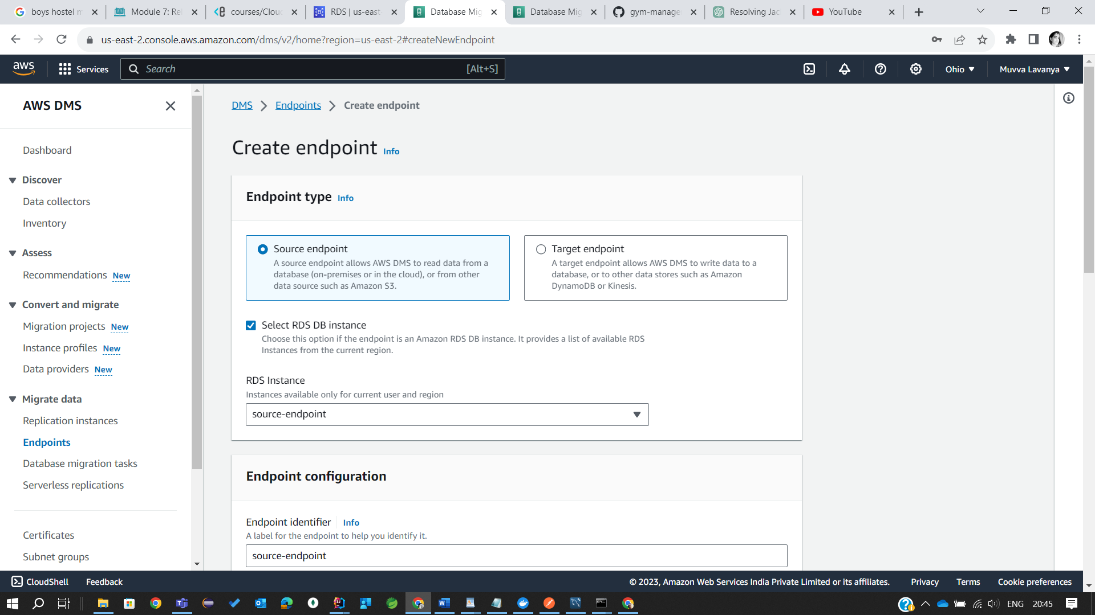

Target Endpoint

1. Create new database migration task.

5. Once you created the task, the migration should start. You can view the progress from the tasks tab in the console.

After successful migration to target-endpoint rds

Sub-task 3 - Update your Main microservice

1. Update your Main microservice application configuration with the newly created RDS database instance property values.

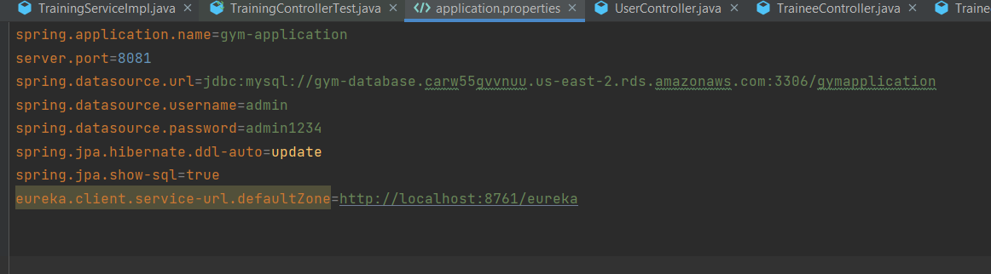

2. Replace .tar Docker image uploaded to S3 in [Module 5: EC2](https://epam-my.sharepoint.com/epmc-acm-public/aws-associate-training/-/blob/CloudX_Associate_AWS_Java_TShape_Developer_theory_impovements/courses/CloudX_Associate_AWS_Java_TShape_Developer/tasks/ec2/README.md) with the new one.

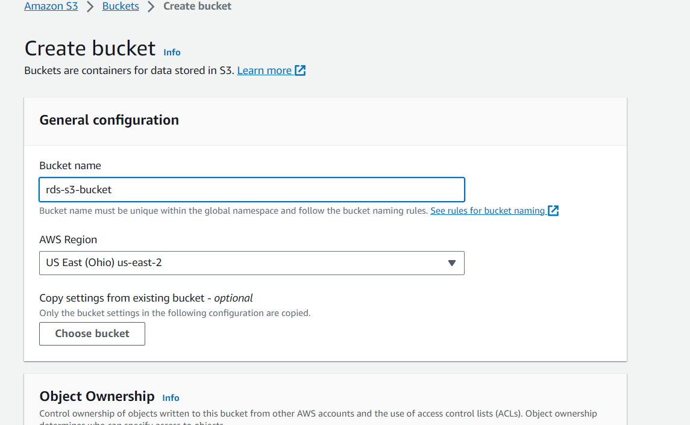

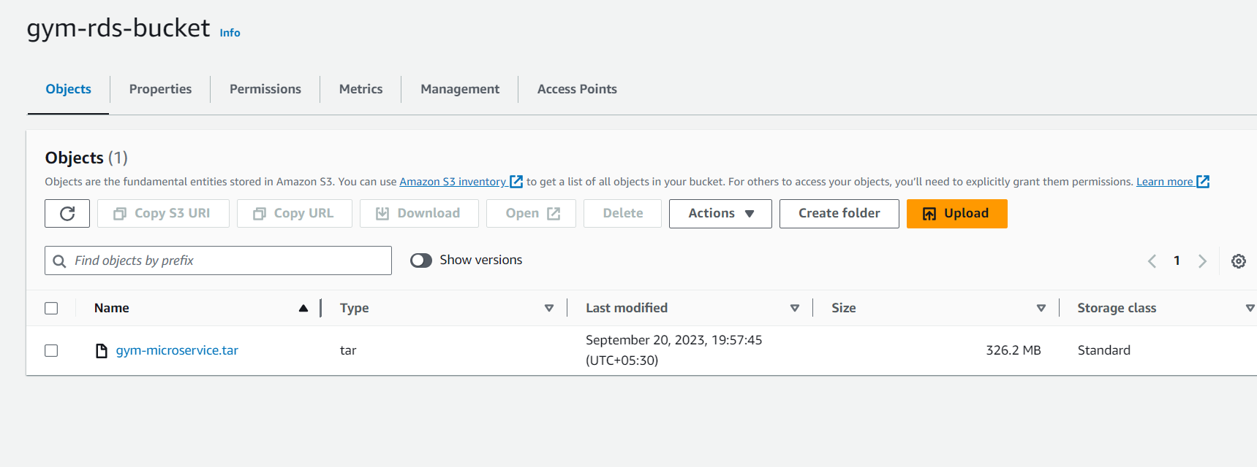

3.Run updated ***Main microservice*** EC2 instance. Verify that application is connected to RDS instance.

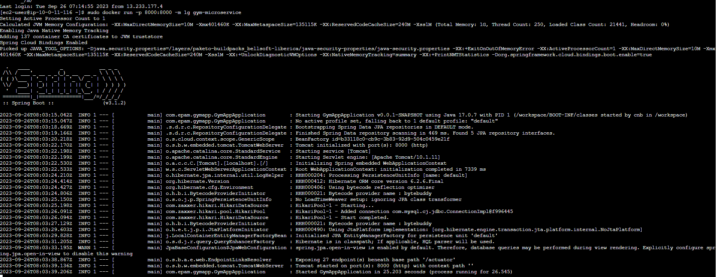

4.Make some calls to created in step 3 microservice instance. Verify that integration with RDS works as expected.

